V_{s2}
i₂
R₂
i_{L}
i₅
i₄
i₁
R₅
R₄
R₁
A
C
D
B
R₃
i₃
V_{s1}
R_{L}
EXPERIMENT 2a. Report form.

Fig.1.Circuit under test

Table 1. Circuit elements :
R1  k Ω | R2  k Ω | R3  k Ω | R4  k Ω | R5  k Ω | R6(R_{L})  k Ω | V_{S1}  _{V} | V_{S2}  _{V}

TASK 1. Open circuit voltage measurement.
Insert SPICE circuit enabling us to measure open circuit voltage (remove load resistor. Place this voltage in Table 2 (complete the table with laboratory measurement and homework calculations)

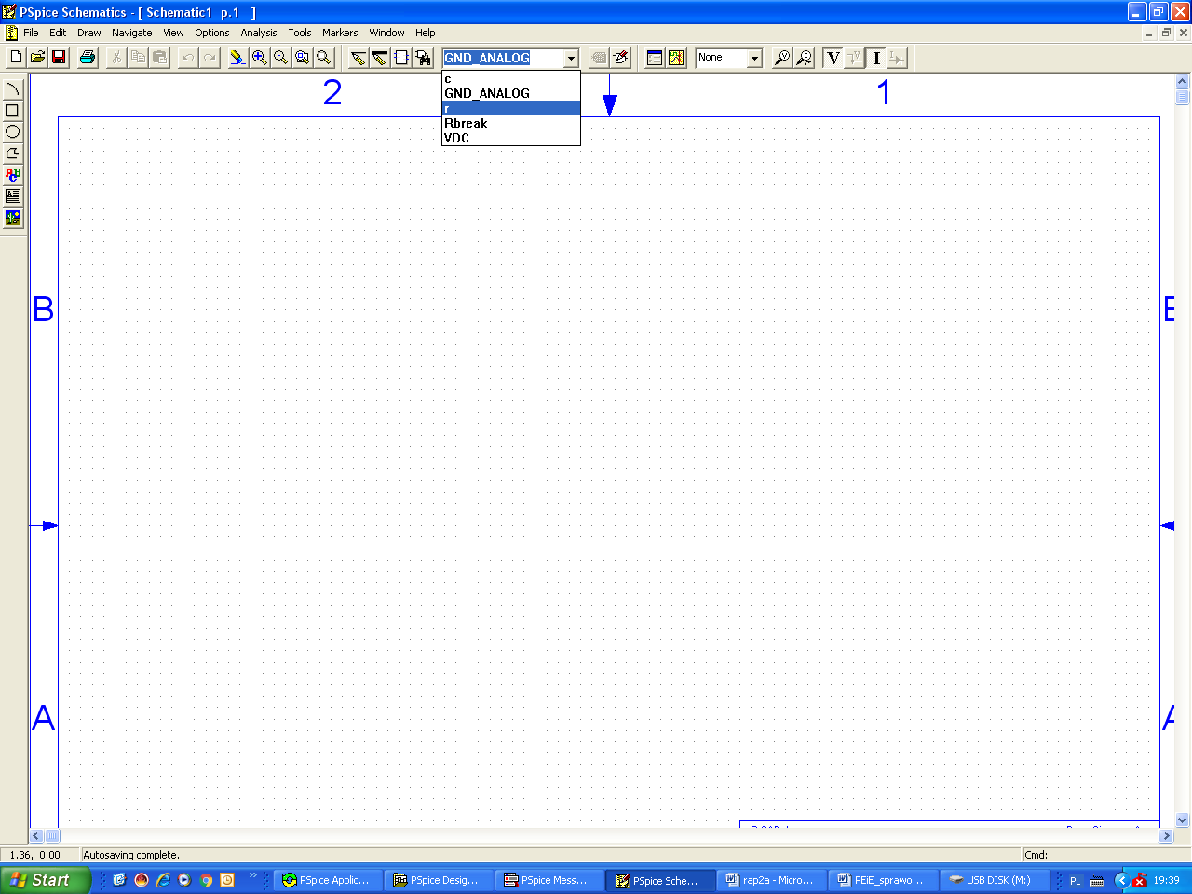

Table 2.
 | Lab.  Meas. | Home  Cal. | Spice  Simul.
V_{eq} (V_{OC} ) _{V}

TASK 2. Short-circuit current measurement.
Insert SPICE circuit simulating short-circuit current i_{s} measurement. Place this result in Table 3 (add laboratory measurement and homework calculation).
HINT: Model the short-circuit branch by resistor having small value or voltage.

Table 3.
 | Lab.  Meas. | Home  Cal. | Spice  Simul.
i_{S}
_{mA}

l
TASK 3. Equivalent resistance measurement.
Insert SPICE circuit R_{eq} measurement simulation. Place this result in Table 4 (add laboratory measurement, homework calculation and result following from v_{eq} and i_{s} simulations), attach calculations!
HINT: SPICE is not equipped with ohmmeter – use standard definition of resistance.
Table 4.
 | Lab.  Meas. | Home  Cal. | v_{eq}/i_{s}  from simulations | R_{eq}  _{from direct SPICE simulation}
R_{eq}
k Ω

TASK 4. Current i_{L} measurement.
Insert SPICE simulation of Thevenin’s and Norton’s equivalent circuits used to calculate load resistance current i_{L}. Fill Table 5 .

Table 5.
 | Lab.  Meas. | Home  Cal. | From Thevenin’s  circuit | From  Norton’s  circuit
i_{L}
mA

TASK 5. Branch currents calculations.
Simulate all circuits (in SPICE program) necessary to confirm superposition theorem (for circuit presented in Fig.1).
Complete Table 6.
Copy appropriate schemes from the simulator containing current values with reference directions.
TABLE 6
Measured →  currents | i₁ | i₂ | i₃ | i₄ | i₅ | i_{L}
Acting sources ↓ | mA | mA | mA | mA | mA | mA
V_{s1}
Vs₂
Vs₁ and Vs₂
Algebraic sum of responses

