Problem 1. Magnetic field of an air-cored solenoid.

Fig.1.Air-cored solenoid.

The air-cored coil shown in Fig.1 is built out with 800 turns of 18 AWG copper wire.
For the following data:
$$L=\text{.}\text{.}\text{.}\text{.}\text{.}\text{.}\text{.}\text{.}\text{.}\text{.}\text{.}\text{mm}, r_{1}=\text{.}\text{.}\text{.}\text{.}\text{.}\text{.}\text{.}\text{cm}, r_{2}=\text{.}\text{.}\text{.}\text{.}\text{.}\text{.}\text{cm}$$

- Propose the FEMM model of coil, observe flux density (B) and field intensity (H) .
- Plot B(x) and H(x).
- Calculate the inductance L using FEMM tools (energy stored). Complete the Table 1.

Table 1
 | Method
 | Analytical | FEMM | Error
L [H] AWG 18
Remarks:
- Apply asymptotic boundary condition (Mixed), set c₁=0, calculate c₁ from the following formula:
$$c_{o}=\frac{1}{μ_{r}μ_{o}R}$$
where R is the outer radius of a spherical problem domain
- Attach calculations.

Problem 2. Magnetic field of an steel-cored solenoid
Data:
$$L=\text{.}\text{.}\text{.}\text{.}\text{.}\text{mm}, r_{1}=\text{.}\text{.}\text{.}\text{.}\text{.}\text{.}\text{cm}, r_{2}=\text{.}\text{.}\text{.}\text{.}\text{.}\text{.}\text{cm}$$

The iron-cored coil from Fig.1 is built out with 800 turns of 18 AWG copper wire (as in the previous case). Propose the FEMM model of coil, observe flux density (B) and field intensity (H), plot B(x) and H(x) and compare. How to calculate inductance this time?

Problem 3: Find mutual inductances of air-cored coils.
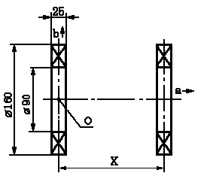
Fig.2. Coupled air-coils.

Find the dependence of mutual inductance of coaxial cylindrical air-cored coils upon the distance x between them.
Remarks:
- For different value of the distance x measure the flux across the right coil for assumed value of current supplying the left one (it is built out of 100 turns of arbitrary copper)
- Due to the symmetry only one quarter of the coils system can be defined.
- Choose appropriate boundary conditions (vertical and horizontal axis)
Table 3
distance x  mm | flux | M
distance x  mm | μWb | μH
10
:
200

Problem 4: Electromagnetic actuator.
Design the FEMM model of the electromagnetic actuator shown in Fig.3.
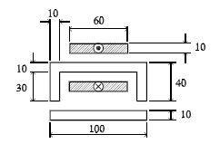
Fig.3.

Observe flux lines and flux density maps for different values o fair gap. Measure forces for several values of air gaps and few values of supplying currents. Attach calculations, describe methodology. (tabulate and plot results)

